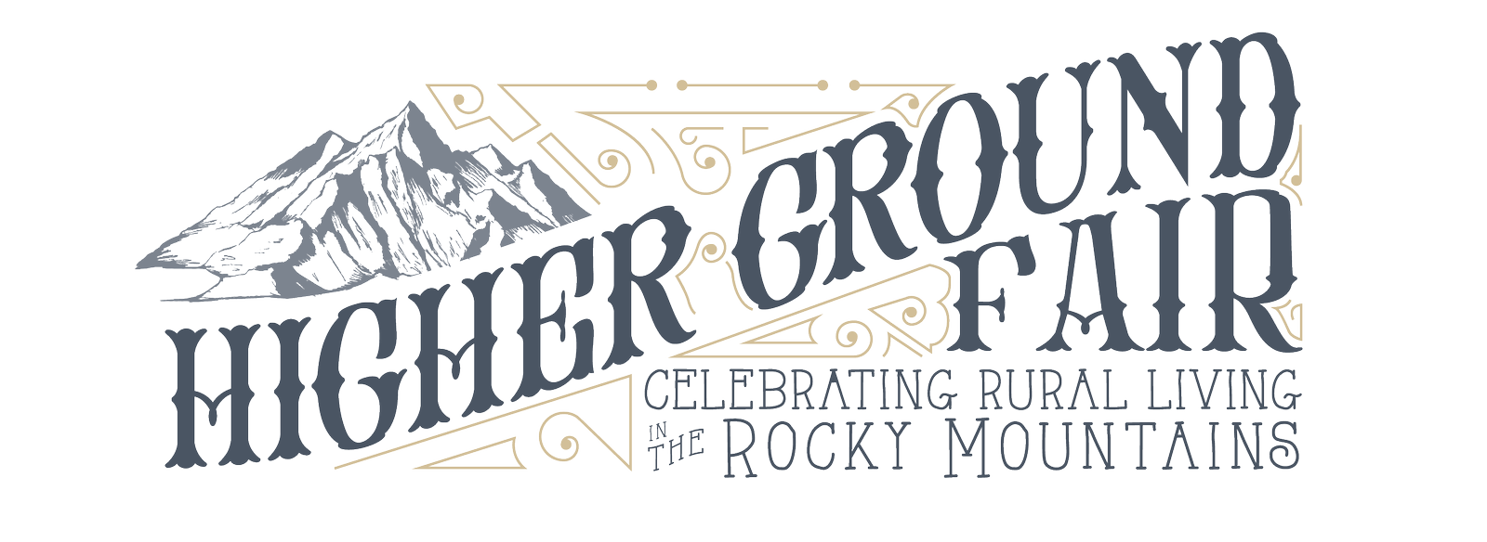

2023 Higher Ground Fair Quilt Show Entry Form

September 16 & 17, 2023 Wyoming Territorial Prison State Historic Site, Laramie, Wyoming.
Please read the registration guidelines (page 4) before completing this form.
A separate entry form must be completed for each item.

ENTRY FORMS MUST BE POSTMARKED BY FRIDAY, AUGUST 18
QUILTS MUST ARRIVE BY 6 PM THURSDAY, SEPTEMBER 14

We appreciate your willingness to share your quilts with us at the Higher Ground Fair.
Thank you for your contribution!

Individual or Group Name: _____________________________________________________________

Street: ______________________________________________________________________________

City: _______________________________________ State: _____ Zip/Postal Code: _______________

Primary Phone: ___________________________ Alternate Phone: _____________________________

E-Mail: _____________________________________________________________________________

Does the quilter or quilt owner live within one of the six Rocky Mountain States or Native First Nations as described in the quilt show guidelines? [Circle one] Yes No

About the Item
Name of Quilt: _______________________________________________________________________

Quilt Owner: ________________________________________________________________________

Quilted by: [List all participants] ________________________________________________________ ___________________________________________________________________________________

Quilt Size (inches): Length __________ Width __________

Is this quilt for sale? [Circle one] Yes No Asking price: ____________
To be judged: [Circle one] Yes No

Description: In 250 words or less please tell us your quilt’s story. Describe the materials used, where they are from geographically, date started and completed, method of quilting, technique used, type of quilt, and whether it is an original design or the inspiration for the design. If you are submitting a heritage quilt, please include the history of the quilt. Please Note: Narrative of your entry will be on display with your entry. Attach additional page if additional space is needed.
Entry Fees (fee must accompany entry form)

Display only No fee
Item for judging $10 each
3 or more items for judging $25

Payment may be submitted online at https://www.highergroundfair.org/payments or by mail.
Checks should be made out to Higher Ground Fair. No cash accepted.

Categories
Descriptions listed below.
For judged items: Prizes will be awarded to 1st, 2nd and 3rd place in each category. Additionally, 1st through 6th place ribbons will be awarded in each category.

Check all categories that apply to this quilt:

☐ Hand Quilted: Quilt must be predominantly completed by hand; quilts can be any technique; at least 75% of quilting must be done by hand.

☐ Machine Quilted: Quilt must be predominantly completed by either a moveable machine, stationary machine, or both.

☐ First Quilt – Youth (ages 4 – 18): Quilt must be predominantly made by someone between the ages of 4 and 18.

☐ First Quilt – Adult (ages 19 – 59): Quilt must be predominantly made by someone between the ages of 19 and 60.

☐ First Quilt – Elder (ages 60 and over): Quilt must be predominantly made by someone aged 61 or older.

☐ Collaborative Quilt: Made by two (2) or more quilters. Names of each participant must be included in the entry form.

☐ Heritage Quilt (display only): Antique or historical quilts are eligible. Dates of any alteration to the original (restoration, repairs, etc.) must be listed in the entry form.

Photos of the quilt should be sent with each entry form or if registering online, emailed to info@highergroundfair.org with the subject line “Higher Ground Quilt Show Entry”
Mailing address for entry forms: Address for quilt mailing only:
Higher Ground Fair Higher Ground Fair
P.O. Box 536 c/o Feeding Laramie Valley
Laramie, WY 82073 968 North 9th Street Laramie, WY 82072

All mailed-in quilts must be sent with sufficient return postage.

By my signature below,
- I understand that all quilt entries must remain on display until 4 p.m. Sunday, September 17, 2023.
- I understand and acknowledge that neither Higher Ground Fair, Action Resources - Feeding Laramie Valley, nor the Albany County Fairgrounds insures this entry and are not responsible if it is lost, stolen, or damaged.
- I understand that if I desire to have this item insured it is my responsibility to insure it.
- I agree that my entry will be clean, and smoke/odor free.
- I understand that the Higher Ground Fair staff reserves the right to make the final decision on how quilts are displayed, and that some quilts may be folded for display in order to allow room for other quilts.
- By entering this item in this quilt show, I give permission for photos to be taken of my entry for noncommercial uses. I authorize the Higher Ground Fair to use a photographic image of my quilt and the entry information as stated above, as an identifier of this quilt on their website and in promotional materials.
- For questions, contact HGF Staff at 307.223.4399 info@highergroundfair.org

Signature: __________________________________________________ Date: ___________________

If under 18
Parent/Guardian Signature: _________________________________________ Date: _______________

Quilt Entry Guidelines

- Quilter(s) may submit their completed work by submitting an entry form, 2 digital photos, and the story behind the quilt.
- Quilter(s) must live within one of the six the Rocky Mountain states of Colorado, Idaho, Montana, New Mexico, Utah, and Wyoming, and the Native First Nations of the region.
- Quilts may be entered in a maximum of two (2) categories.
- Quilts must be no larger than 60" in width and 74" in length.
- All quilts must remain on display until 4 p.m. Sunday, September 18, 2022.
- Two photos must be submitted with the entry:
  - A full-view photo of the completed quilt showing all four corners of the quilt. No part of the quilt may be obscured.
  - A photo of the entrant(s) from the shoulders up. If a group is submitting, please use a photo that includes all of the participants.
- A brief narrative of the quilt must be uploaded with an entry including but not limited to: Materials used and where they are from geographically, start and completion date, the technique used, type of quilt, and inspiration for the design.
- Quilts must be clean, free of odor, and in excellent condition. Quilts that are soiled, torn, or incomplete will be disqualified for both entry and display.
- Entries may be mailed or hand-delivered to the Higher Ground Fair Home Office
- Please note: the mailing address for entry forms and for quilts is not the same!
- Quilts will be accepted for sale. If you are interested in selling your quilt, indicate it and the price on the registration form.

